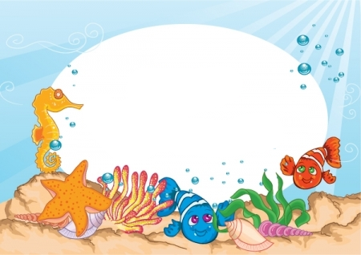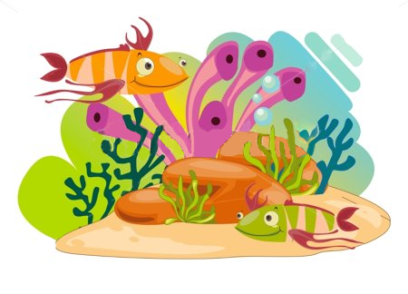**Suggested (but not limited to) Ideas for Report and Project**

Sea Creature Report Information

The fourth graders will soon begin working on writing informative

paragraphs in class. These paragraphs will be about a sea creature of their choice.

We will begin in class learning to take notes, turn those notes into a rough draft,

and eventually write the final copy at home. They will also be responsible

for creating a project representing their sea creature.

(This can be as simple as a hand-drawn picture.)

As we read the book, *Island of the Blue Dolphins,* students are introduced to

various sea creatures encountered by the main character. This exposure,

as well as some topics covered in our science lessons,

also help to give students some ideas

about creatures they would enjoy researching.

Sea Creature Report Information Acknowledgement

Please sign below, then detach and return this portion to me, by Thursday, September 8th

so I will know you have received the information and are aware

of the time line due dates. Thank you.

Student Signature _________________________________________

Parent Signature _________________________________________

**Basic Timeline**

**Monday, Sept. 12** Students will need at least 12 lined note cards in class.

(The large size works best.)

**Tuesday, Sept. 13** Students will need source(s) in class on a sea creature of their choice. They will learn how to look for information and take notes from a book. Possible topic choices are listed on the next page.

We will work in class on Sept. 13-22.

Unfinished work will need to be done at home.

**Thursday, Sept. 22** Note cards due

**Monday, Sept. 26** Note cards returned in class. We will begin writing the Rough Draft.

We will work on the Rough Draft September 27 – October 4.

Unfinished work will need to be completed at home.

**Wednesday, Oct. 5**  Rough Drafts due

**Friday, Oct. 7** Rough Drafts returned in the Friday Folder.

Begin writing final copy at home.

**Tuesday, Oct. 11** Visual Projects due

**Tuesday, Oct. 18** Final Copies due

|  |  |  |  |
| --- | --- | --- | --- |
| Abalone | Sand Dollar | Cormorant | Squid |
| Crab | Whale | Sea Otter | Star Fish (Sea Star) |
| Dolphin | Shark | Octopus | Anemone |
| Pelican | Shellfish | Mussel | Puffer Fish |
| Seal | Sea Elephant | Sea Gull | Sea Horse |
|  | Sea Urchin | Eels |  |

**Sources – Due Tuesday, September 13**

Students will only be required to have one resource – a library book, encyclopedia, or fourth grade friendly internet article would be fine. It is extremely important that the resource is written on the student’s reading level. Students become very frustrated when trying to take notes from information they have difficulty reading.

**Note Cards – Due Thursday, September 22**

Requirement: At least 5 facts for at least 2 topics. Students may complete more topics as a challenge and for extra credit.

**Rough Drafts – Due Wednesday, October 5**

1. Needs to be hand-written, skipping spaces between each line.

2. Must have three paragraphs which will include an introductory paragraph and two paragraphs of

information. Each paragraph will need a topic sentence and five supporting detail sentences.

Students may complete more paragraphs as a challenge and for extra credit.

3. Cover sheet should include student’s name, date, and the topic (sea creature) chosen.

**Project – Due Tuesday, October 11**

This project will be done at home and you may begin as soon as you choose your sea creature.

Please display your name on your project.

Present your sea creature in some way. Use your imagination! Suggested ideas:

* Poster with various pictures
* Your own hand-drawn picture of your creature.
* A model of your sea creature: clay, carving, etc.
* Diorama in a box of your creature and its habitat

**Final Copy – Due Tuesday, October 18**

1. May be hand-written or typed. Don’t skip spaces this time.

2. Same as number 2 for Rough Draft.

3. Cover must be illustrated (by hand or computer) and must include student’s name, date, and topic.

**Purposes for this combined Reading, Language, and Science assignment:**

1. Students will be learning to take notes, write good complete sentences that support a topic

sentence, and formulate a good paragraph. (Please understand that these reports will look and

sound like 4th grade writing. They should not be copies of an Internet print out.)

2. Learn more about God’s amazing creatures of the sea.