



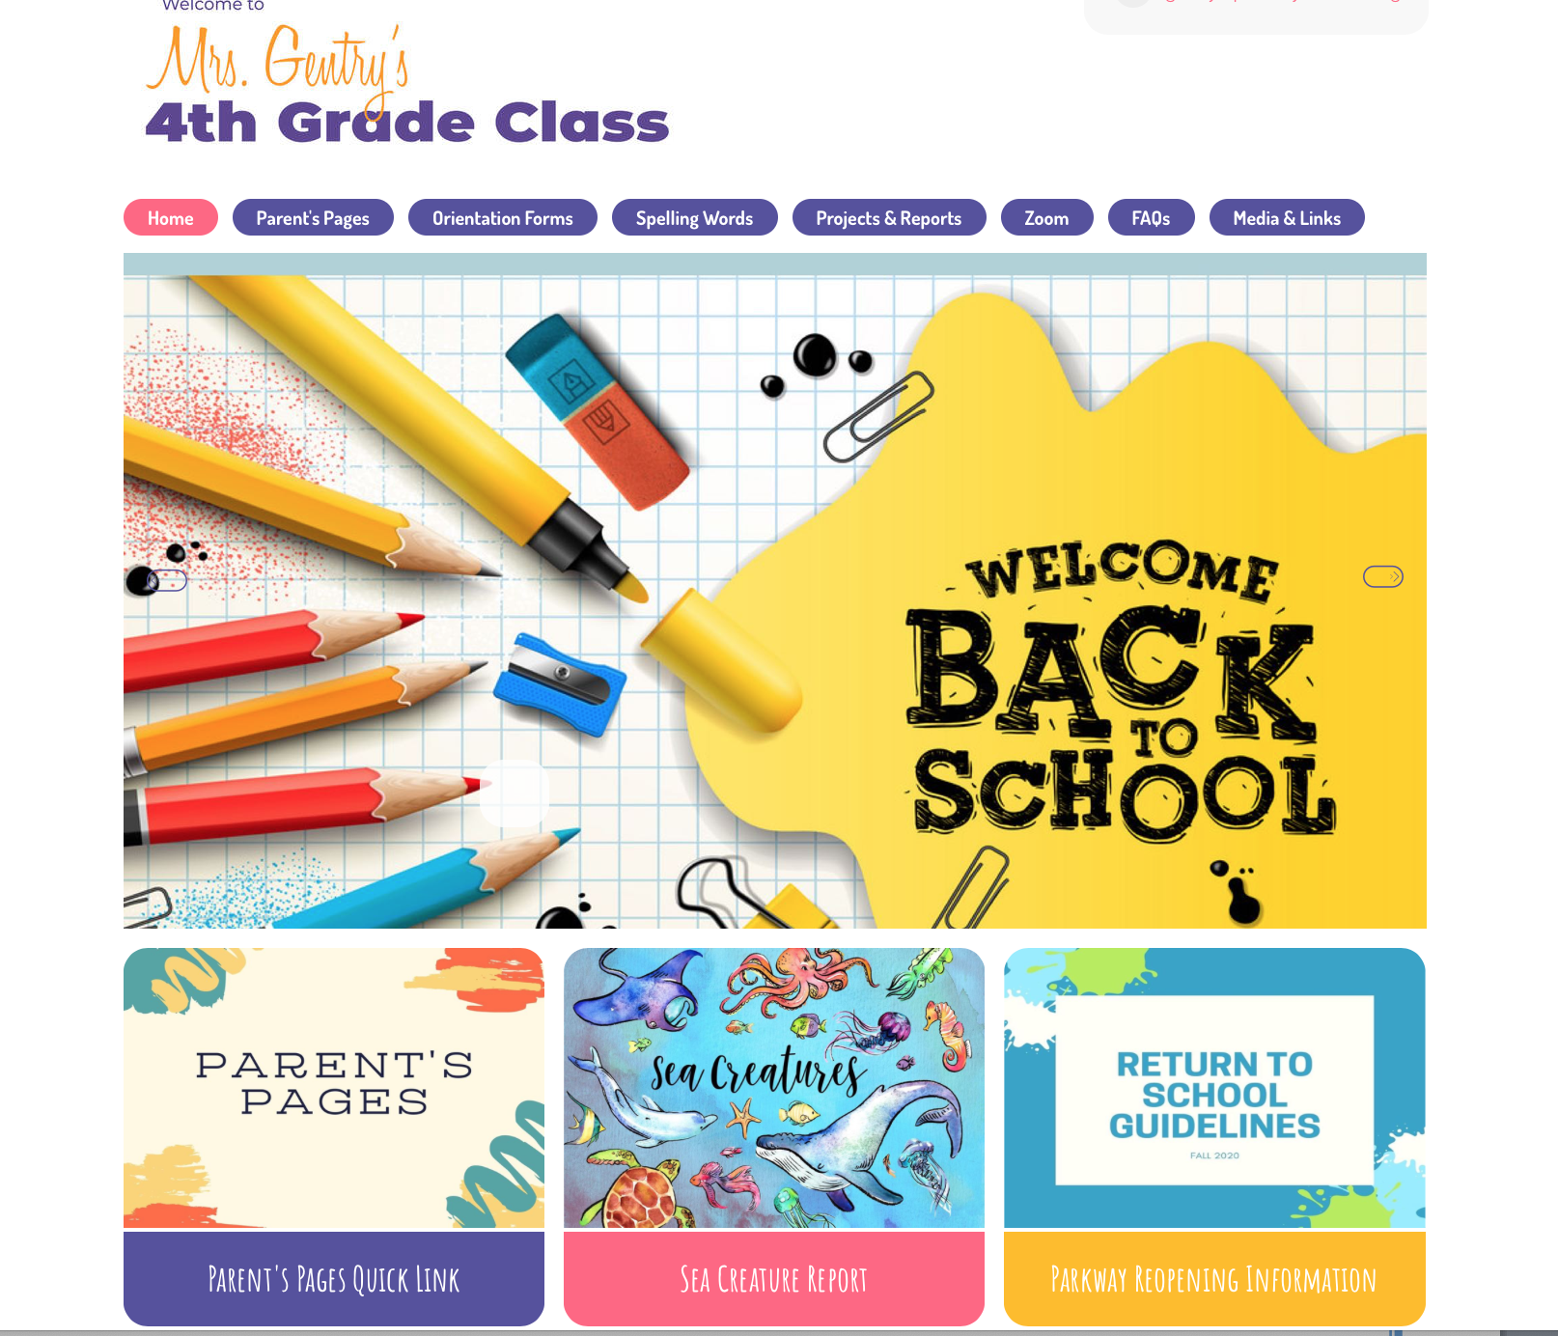

Some of the information you’ll find on the site includes:

Classroom work assignments

* Upcoming tests schedules
* Homework schedules
* Scripture memory information
* Spelling Lists

Projects and Reports Guidelines

Lesson Videos

News flashes of need to know information

You’ll be able to contact me via e-mail very easily from this site. For your information my e-mail address is:

lgentry@parkwaychristian.org